**🧱 OVERVIEW**

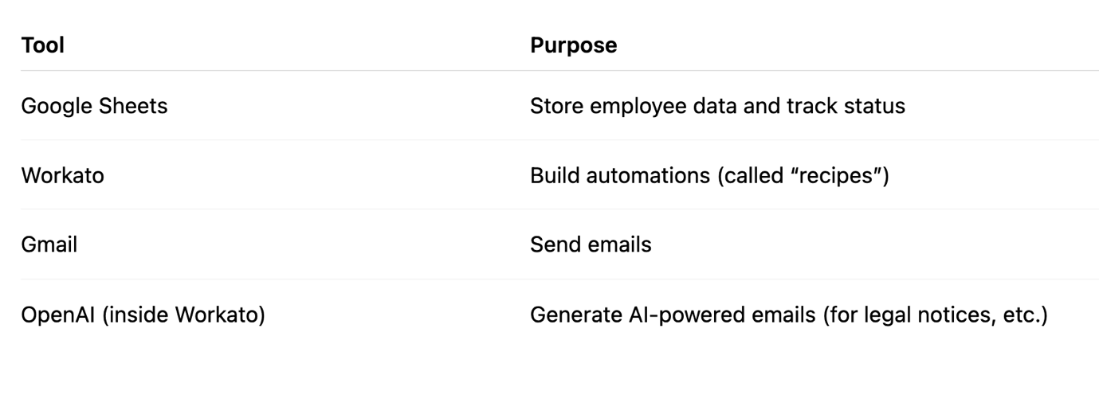

**🧾 DATA FILE YOU WILL USE**

You will only use this one file (already generated earlier):  
📥 FnF_Automation_Master.xlsx

**🧭 FULL STEP-BY-STEP GUIDE**

**✅ STEP 1: PREPARE GOOGLE SHEET**

**1. Open the sheet**

* Upload the Excel file to your Google Drive
* Right-click → Open with → **Google Sheets**
* Click **File → Save as Google Sheets**
* Rename it as: FnF_Automation_Master

✅ Done. Keep this tab open — Workato will connect to this sheet.

**✅ STEP 2: CREATE WORKATO ACCOUNT & START A RECIPE**

**1. Open Workato**

* Go to: <https://www.workato.com>
* Click **Sign Up**
* Choose **“Sign up with Google”**
* Select your Google account (same as your Google Sheet)

**2. Create a New Recipe**

* From the left menu, click **Recipes**
* Click **+ Create Recipe**
* Fill:
  + Name: FnF Automation Bot
  + Folder: My Recipes or default
* Click **Create Recipe**

**✅ STEP 3: SET DAILY TRIGGER**

**1. Trigger Configuration**

* Search for app: Scheduler
* Select: New scheduled event
* Click **Next**
* Set Frequency: Daily
* Time: Choose 09:00 AM
* Click **Next**
* Click **Start Building**

✅ Now this recipe will run every morning automatically.

**✅ STEP 4: FETCH EMPLOYEE DATA FROM GOOGLE SHEET**

**1. Add Action: Search Rows**

* Click the **“+”** button below the trigger block
* App: **Google Sheets**
* Action: **Search rows**
* Click **Next**

**2. Connect to Google Account**

* Click **Connect an account**
* Choose your Google account
* Allow permissions
* Click **Next**

**3. Configure Google Sheets Access**

* Spreadsheet: FnF_Automation_Master
* Worksheet: Sheet1
* Leave “Search conditions” blank
* Click **Next**

✅ Now Workato will read all employees listed in the sheet.

**✅ STEP 5: LOOP OVER EACH EMPLOYEE**

**1. Add Repeat Block**

* Click the **“+”** under the Search rows step
* Select: **Repeat action**
* For each: row in Google Sheets result
* Click **Next**

Now, everything we do next will be inside this loop — for each employee one-by-one.

**✅ STEP 6: ADD IF CONDITION – LWD -1 REMINDER**

**1. Add IF condition**

* Inside the loop, click **“+”**
* Choose: **If condition**
* Formula:

sql

CopyEdit

format_date(today()) == format_date(date_add(row['LWD'], -1, 'days'))

**2. Inside that IF:**

* Click “+”
* App: Gmail
* Action: **Send email**
* To: {{row['Work Email']}}
* Subject: Reminder: Submit Attendance & Allowances before LWD
* Body:

css

CopyEdit

Dear {{row['Employee Name']}},

Please make sure to submit all attendance and allowances before your last working day: {{row['LWD']}}.

Regards,

HR Team

**3. Update Sheet:**

* Add Google Sheets → Update row
* Select the row using: {{row['ID']}}
* Set Reminder 1 = Sent

✅ This prevents resending the reminder again tomorrow.

**✅ STEP 7: SEND CHECKLIST ON LWD (LWD = Today)**

Repeat the above with a new IF condition:

sql

CopyEdit

format_date(today()) == format_date(row['LWD'])

Inside that:

* Send Gmail with checklist (ID return, asset clearance)
* Update: Reminder 2 = Sent

**✅ STEP 8: REMIND IF ASSET NOT RETURNED**

Repeat this 4 times with IF conditions:

sql

CopyEdit

format_date(today()) == format_date(date_add(row['LWD'], X, 'days')) AND row['Asset Returned'] == "No"

Where X = 7, 14, 21, 32

Inside each block:

* **Gmail → Send email**
  + To: {{row['Personal Email']}}
  + Subject: Reminder: Please return company assets
  + Body:

csharp

CopyEdit

Dear {{row['Employee Name']}},

Our records show that you have not yet returned company assets post your last working day ({{row['LWD']}}). Kindly do so as soon as possible to avoid legal consequences.

Regards,

Asset Management Team

* **Update Sheet:** Legal Notice = Reminder X Sent

**✅ STEP 9: FINAL LEGAL NOTICE USING AI (MANDATORY)**

**1. IF: Today = LWD + 32 and Asset Returned = No**

Use IF condition:

python

CopyEdit

format_date(today()) == format_date(date_add(row['LWD'], 32, 'days')) AND row['Asset Returned'] == "No"

**2. Add OpenAI Step (Inside IF)**

* Click “+”
* App: **OpenAI**
* Action: **Generate text**
* Prompt:

css

CopyEdit

Write a formal legal email to {{row['Employee Name']}} who has not returned company assets by 32 days after their LWD ({{row['LWD']}}). Keep tone polite but firm.

**3. Add Gmail Email**

* Use OpenAI response in the **body**
* To: {{row['Personal Email']}}
* Subject: Final Legal Notice: Non-return of Company Property

✅ This is your AI-powered, smartly generated content!

**✅ STEP 10: FNF CALCULATION – ON LWD + 6**

**1. IF: format_date(today()) == format_date(date_add(row['LWD'], 6, 'days'))**

**2. Inside that:**

* Add Formatter → Compose text
* Content:

css

CopyEdit

Name: {{row['Employee Name']}}

LWD: {{row['LWD']}}

Asset Returned: {{row['Asset Returned']}}

Dues: ₹{{row['Dues (₹)']}}

Clearance Status: {{row['Clearance Status']}}

* Add Gmail → Send email to:
  + To: finance@company.com
  + Subject: FNF Input for {{row['Employee Name']}}
  + Body: Use composed text

**✅ STEP 11: FINAL SETTLEMENT STATUS**

**1. Add IF conditions:**

* If Dues < 3000 → Auto write-off
* If Dues > Net Payable → Negative settlement
* Else → Mark as Paid

**2. Gmail for positive:**

* Subject: Your F&F Settlement has been processed
* Body:

css

CopyEdit

Dear {{row['Employee Name']}},

Your Full & Final Settlement has been processed. Net Amount: ₹{{row['Net Settlement']}}.

Regards,

HR Payroll

**3. Gmail for negative:**

* Ask them to transfer remaining amount to company account
* If still unpaid after 7+7 days → flag as **Delinquent**

**✅ STEP 12: SHEET UPDATES**

Every time you:

* Send reminder
* Send legal notice
* Mark final payout

→ Always add a Google Sheets → Update Row action to record the action (ex: Status = Paid, Legal Notice = Sent, etc.)

**✅ BONUS: DASHBOARD (IN GOOGLE SHEET)**

Create a new tab called Dashboard. Add:

| **Metric** | **Formula** |
| --- | --- |
| Total Employees | =COUNTA(A2:A) |
| In Progress | =COUNTIF(H2:H, "In Progress") |
| Completed | =COUNTIF(O2:O, "Paid") |
| Delinquent | =COUNTIF(O2:O, "Delinquent") |

✅ Add pie/bar charts using Insert → Chart

**✅ WHAT YOU’VE BUILT NOW:**

* ✅ Daily automated schedule
* ✅ Employee-wise loop
* ✅ LWD reminders and checklist
* ✅ Asset return tracking
* ✅ AI-powered legal email
* ✅ FNF file generation and finance alert
* ✅ Positive/negative payout logic
* ✅ Smart sheet tracking and dashboard

Bottom of Form